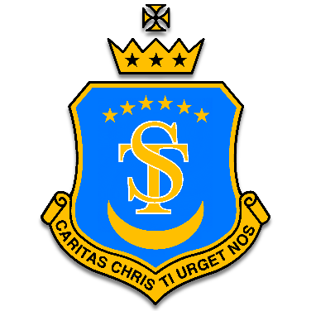
St Teresa's Catholic Primary School
“With Jesus we Live, Love and Learn.”
Elsenham Crescent,
Basildon,
Essex, SS14 1UE
Telephone:01268 553502
Email: office@st-teresasrc.essex.sch.uk
Headteacher: Mr Jacques F Bottjer (B.Ed)

School holiday and inset dates 2025-2026

Dear Parents and Guardians,

Please see attached dates for school holidays for academic year 2025-2026. These are the dates for school holidays and inset (non-pupil) days for next academic year.

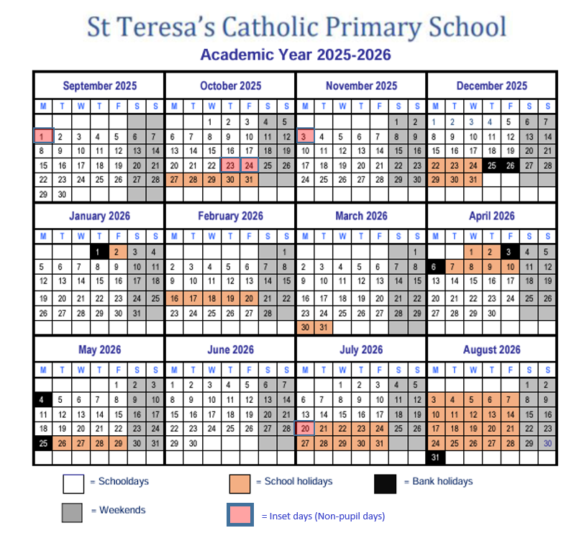
Warm regards,
Mr. J Bottjer
Head Teacher
St Teresa's Catholic Primary School

